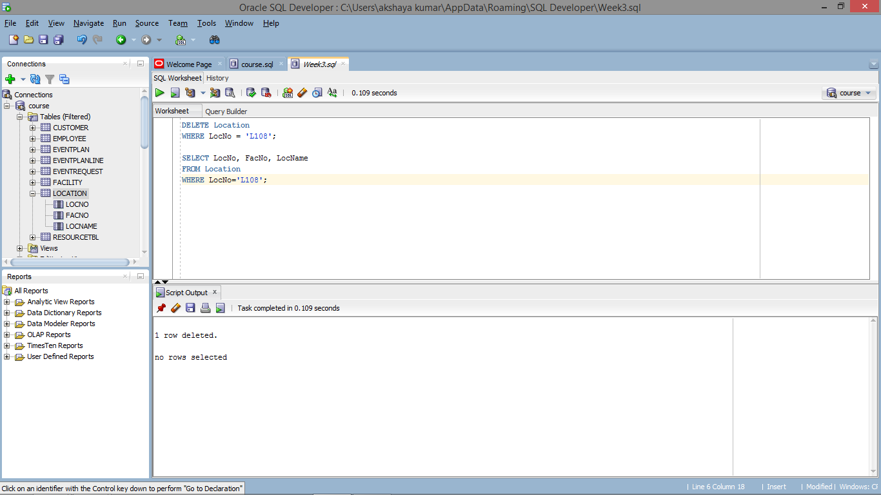

DELETE Location

WHERE LocNo = 'L108';

SELECT LocNo, FacNo, LocName

FROM Location

WHERE LocNo='L108';